Задание 40. Тренировочный тест 2. Варианты 2. Тема образования.
- ВАРИАНТ 2

Imagine that you are doing a project on motives to learn languages for young people. You have found some data on the subject – the result of the opinion polls (see the graph below).
Comment on the data in the graph and give your personal opinion on the subject of the project.

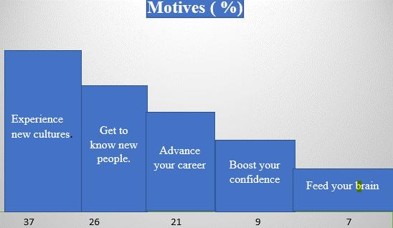
Write 200-250 words.
Use the following plan:
- make an opening statement on the subject of the project work;
- select and report 2-3 facts;
- make 1-2 comparisons where relevant;
- outline a problem that can arise with the motives of learning languages and suggest a way of solving it;
- conclude by giving your opinion on how learning languages impacts young learners.

