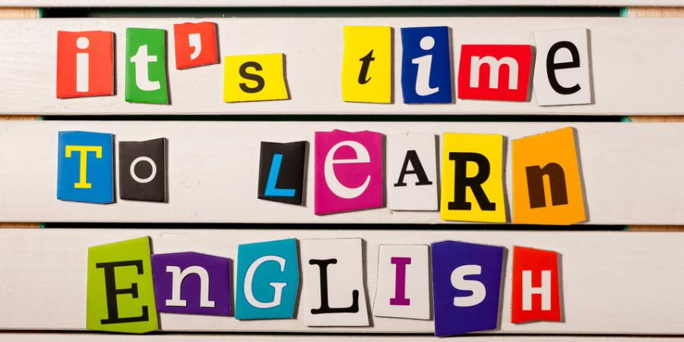

Задание 39. Электронное письмо личного характера.
Тема “Образование”.
Тренировочный тест 2.
Напишите письмо другу, соблюдая все правила, представленные в уроке. Обращайте особое внимание на:
- структуру текста и оформление письма;
- раскрытие содержания, сохраняя при этом логичность высказывания, не превысив установленный лимит слов (100–140).
- соблюдение норм вежливости и правильного стиля речи.
- использование лексико-грамматических средств.
You have received a letter from your English-speaking friend Alice who writes:
From: Friend@mail.uk
Subject: Welcome
You know, I am planning to sign up for a language course at our school I am aware that learning foreign languages takes time and dedication but as for me it is necessity. It happens that I am going to study in Spain. By the way, what is your favorite subject at school? How many English lessons a week do you have? What do you want to become?
As for my other news, next month I am going to Russia.

Write an email to Alice. In your message answer her questions, ask 3 questions about her plans to travel to Russia. Write 100−140 words. Remember the rules of email writing.

