Тема “Leisure activities”.

Задание 40.
Тренировочный тест 2. Вариант 2.

Imagine that you are doing a project on doing a project on the benefits of having leisure activities. You have found some data on the subject – the result of the opinion polls (see the table below).
Comment on the data in the table and give your personal opinion on the subject of the project.
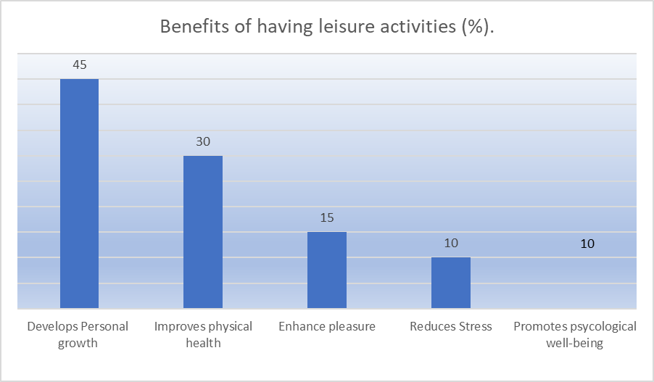

Write 200-250 words.
Use the following plan:
- make an opening statement on the subject of the project work;
- select and report 2-3 facts;
- make 1-2 comparisons where relevant;
- outline a problem that can arise due to the lack of free time activities and suggest a way of solving it;
- conclude by giving your opinion on the effect of free time activities on life quality of youth.

